For more information about other Microsoft customer successes, please visit: www.microsoft.com/casestudies
Customer: Shared Spectrum Company
Website: www.sharedspectrum.com
Customer Size: 26 employees
Country or Region: United States
Industry: Engineering—Electrical engineering
Partner: Brittenford Systems

Customer Profile
Based in Vienna, Virginia, Shared Spectrum Company is a government contractor focused on establishing new technologies that leverage the radio frequency spectrum.

Software and Services
- Microsoft Dynamics
- Microsoft Dynamics SL
Microsoft Dynamics
Customer Solution Case Study
 | 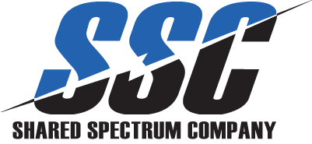 |  | Government Contractor Improves Insight, Reporting With Cloud-Based Project Accounting Solution
“Not only did Microsoft Dynamics SL cost about 15 percent less than Deltek Vision, it is also flexible enough to support a commercial business environment when our products catch on in the private sector.”
Dan Simmon, Controller, Shared Spectrum Company

Business Needs
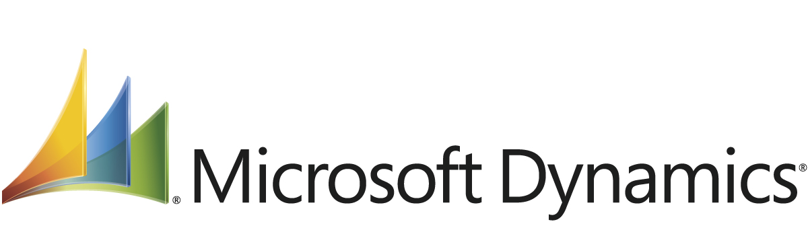

Founded in 2000, Shared Spectrum Company (SSC) is a government contractor focused on developing technology that dramatically increases the use of the radio frequency (RF) spectrum. Since its founding, the company has become an expert and innovator in the development of cognitive radio technologies and pioneered the development of Dynamic Spectrum Access (DSA) technology for the US Department of Defense.

As a small, growing company, SSC had relied on Intuit QuickBooks for nine years to manage accounting and Microsoft Excel for project management. For a company that once had a single, large government contract, QuickBooks worked well. But, by 2009, SSC juggled multiple contracts and projects, making the tying together of financial and project management data an increasingly cumbersome task.

“We had no insight into a project until we ran month-end financials and related those financials to a project by using Excel,” says Dan Simmon, Controller for Shared Spectrum Company. “With 16 simultaneous projects and reporting that took as long as two hours per project, there wasn’t enough time to report at a faster interval and perform the rest of my job.”

At the same time the company aimed to ease project accounting, it also sought to simply gain new functionality to support several key business processes. Of these, the company wanted to automate timecard processing and government reporting, primarily as it pertained to Defense Contract Audit Agency (DCAA) compliance.

“Accounting for employees’ time was a manual process,” says Simmon. “It took me about four hours twice a month to enter employees’ time into QuickBooks to run payroll.”

SSC also saw that, should its innovations take off in the commercial space, the company would need a more solid infrastructure in place to accompany rapid growth. Says Simmon, “At any point in time, our technologies could become a major hit as they become available to the public, and we needed to be ready for that growth with an integrated project management and accounting system.”

Solution
For its new project management and accounting solution, SSC chose Microsoft Dynamics SL after also closely considering Deltek Vision. Says Simmon, “Not only did Microsoft Dynamics SL cost about 15 percent less than Deltek Vision, it is also flexible enough to support a commercial business environment when our products catch on in the private sector.”

Working with Microsoft partner Brittenford Systems, SSC has begun to deploy Microsoft Dynamics SL in a cloud-based environment hosted by Data Resolution to eliminate IT support and infrastructure requirements. Says Simmon, “As a company with one person in IT and one person in finance, it made a lot of sense for us to go with a hosted deployment of Microsoft Dynamics SL.”

Already, the company has started to use Microsoft Dynamics SL for core processes that span project management, accounting, and timecard processing. Says Simmon, “Now that employees input their hours into Microsoft Dynamics SL, managers can see project financials in near real time.”

Benefits
With Microsoft Dynamics SL in place, SSC has improved project accounting, eased reporting, and laid a solid IT foundation for ongoing company growth. Says Simmon, “By using Microsoft Dynamics SL, we have been able to bring all facets of our business together under one solution— from timecard entry to integrated project management and accounting. Because of this, we can work to streamline our reporting and be ready for whatever opportunities the future may hold.”

Establish Central Source of Truth, Streamline Reporting and Cash Flow
Now, with all project and financial information in one system, SSC can also perform reporting with ease. “Managers used to have to wait until the end of the month for me to run them a report; now they can see real-time reports with a few clicks,” says Simmon. “With Microsoft Dynamics SL, I can report on just about anything that can come down the pipe, which is a nice feeling to have. In addition, the solution makes it possible to get invoices out more quickly, which helps to accelerate our cash flow.”

This central source of truth has also led to measurable improvements:
- Saving 32 hours per month in project accounting by eliminating the need to combine project and financial management information.
- Saving eight hours per month by eliminating the need to manually enter employees’ time for payroll.

Achieve Government Compliance
As a government contractor, having a central source of information has also meant easing compliance, a particular benefit when it comes to DCAA. “With Microsoft Dynamics SL, we have all the information and functionality we need for DCAA reporting,” says Simmon. “We can see our fixed and variable costs and determine the variance between our provisional and actual rates and that variance’s financial effect on individual contracts.”

Enable Ongoing Growth Through Flexible Platform
SSC is now developing its DSA technology and expects that technology to have commercial applications in the near future, leading to rapid company growth. With Microsoft Dynamics SL in place, the company eyes that future in confidence. Says Simmon, “For a growing company, the inflexibility of QuickBooks was becoming a liability. With Microsoft Dynamics SL, we can adapt the system to meet the needs of our business as it continues to change.”

